1. HRM is a perfect platform for re engineering your HR processes and achieving a new level of HR Management.  
     
   Do get in touch with me for complete Information and Demo.

Attached Images Attached Images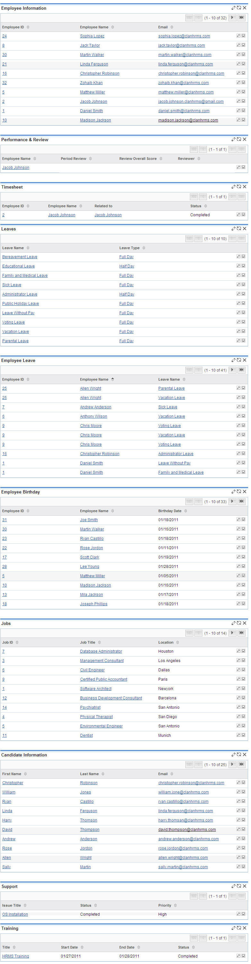 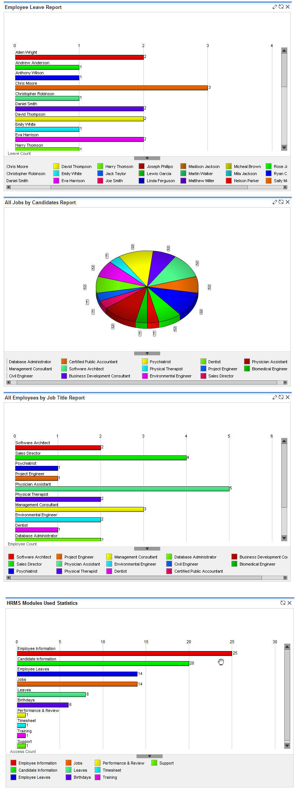

*Last edited by jacob.johnson; 2012-07-23 at 12:17 PM.*

* + [Share](http://forums.sugarcrm.com/f19/new-human-resource-management-system-available-download-now-41813/)
    - http://forums.sugarcrm.com/vbseo/resources/images/forum/digg.gif
    - http://forums.sugarcrm.com/vbseo/resources/images/forum/delicious.gif
    - http://forums.sugarcrm.com/vbseo/resources/images/forum/technorati.gif
    - http://forums.sugarcrm.com/vbseo/resources/images/forum/twitter.png

[Chris_C](http://forums.sugarcrm.com/members/chris_c/) likes this.

[**[Reply With Quote](http://forums.sugarcrm.com/newreply.php?do=newreply&p=142500)Reply With Quote**](http://forums.sugarcrm.com/newreply.php?do=newreply&p=142500)

1. 2009-01-02, 10:54 AM[#2](http://forums.sugarcrm.com/f19/new-human-resource-management-system-available-download-now-41813/" \l "post142505)